DLC

Sean’s House



You enter Sean’s house.

To be honest, it is your first time to visit his home.

“Sean never talks about his family.” You speak to yourself.

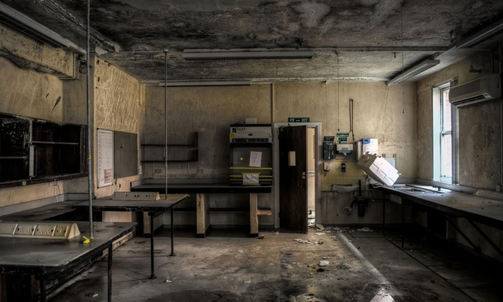

It is too silent around here. You can only hear your breathing.

The door closes by itself. You turn around to have a look, but you then find that the only thing you can do is making the floor creaking.

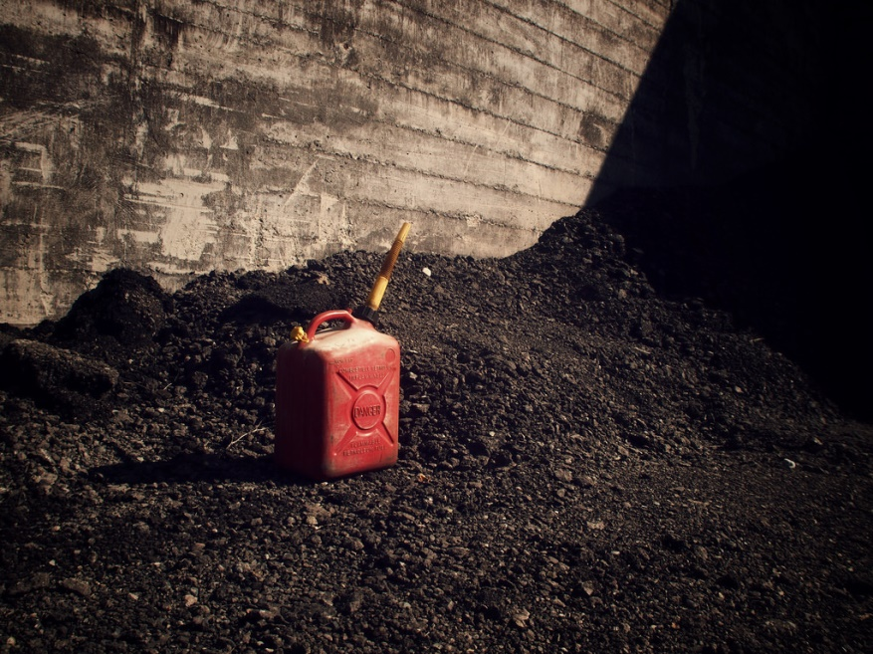

Not too far away, there is a gasoline can on the ground.

Choices:

1. Check it

You find a piece of diary beneath the can.

(Read **Diary I** on the back of this page)

1. Ignore

Everything is normal… at least not that weird.

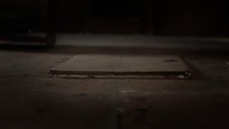Few feet away, there is a **basement entrance** on the ground. Some scratches on the floor lead to the basement. It seems like someone dragged something long ago.

Apparently, it is not a good place to go.

However, suddenly, you see 2 zombies on the upper floor are staring at you. And, the weirdest thing is, one of them is unusually **giant**, and the other one has **ice** on its body.

What will you do?

Choice:

1. Enter the basement

When you closed the entrance, the surrounding again becomes silent.

You find a piece of diary on the ladder (**Diary II**)

1. Try to go back and open the door

You use up all of your strength, but the door seems never closer to you. The giant zombie grabs you and tortures you to **die**.

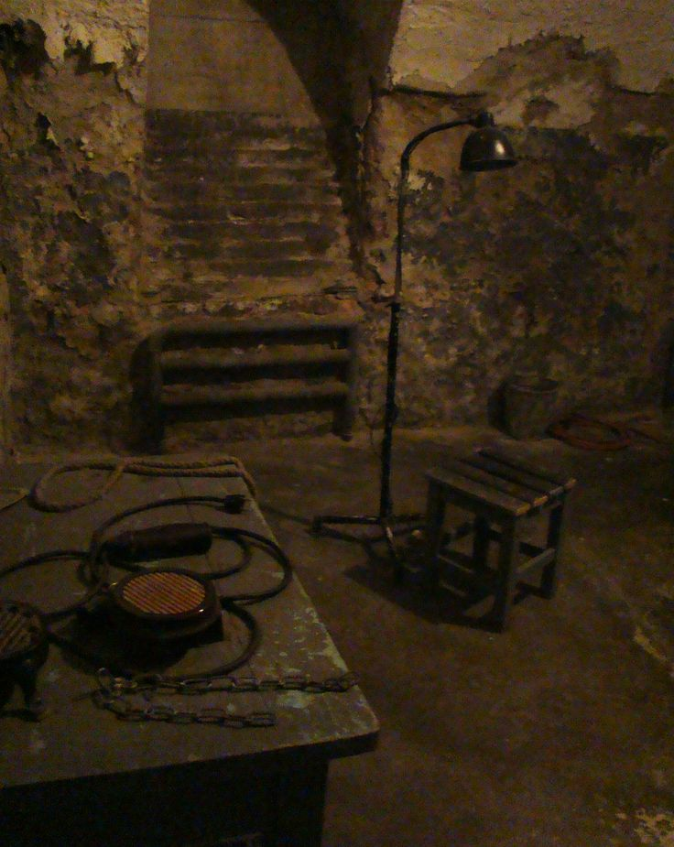The basement is full of dust. Faint light cast through the window, which makes everything looks vague. However, you still recognize the stuffs in this room, which you will never forget.

There is a wooden bed stand in the middle, paint into red by blood.

Nails and ropes are everywhere in the room.

Several metal tools-for torture, to be sure-are hanging on the wall.

Again, you find several things worth checking.

What will you do now?

A broken door that **lamplight** comes out

Opening the door, and you see a familiar giant monster…You get another piece of diary on the ground, which is the last thing you see. (**Diary III**)

A bunch of **camping** equipment in the corner

Things are messily spread, but you still find a piece of diary. (**Diary IV**)

A big **freezer** inside the wall

You find a dead women’s body. Look familiar and totally dried.

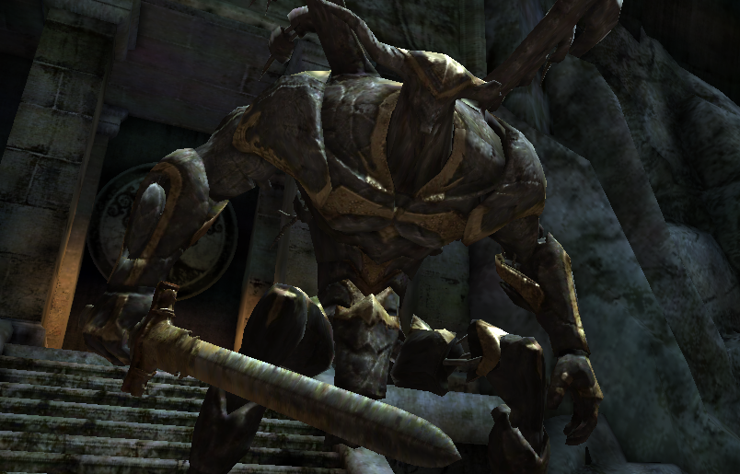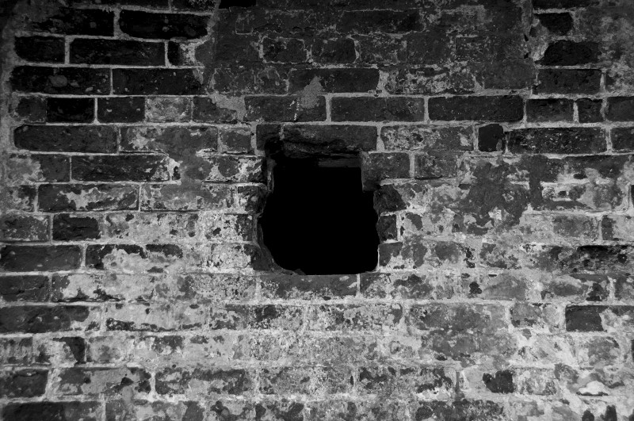After you finished you work, the broken door suddenly opened. A giant, bloody monster walks out, holding a bunch of torture tools.

At that moment, you find a small hole that just allows you to enter. In front of that hole, there are some traces on the ground.

Make a choice:

Escape through the **window**

The window… is an illusion? You touch the window, but it feels like brick. When you are shocked by this fact, the monster gets you.

Hide into the **freezer**

You die with the dead women inside.

Enter the **hole**

“No…no way…you can’t have girlfriend…” Someone is crying deep in the hole.

At the bottom of the hole, a heavily wounded boy is crying on the bed.

Blood soaks the blanket.

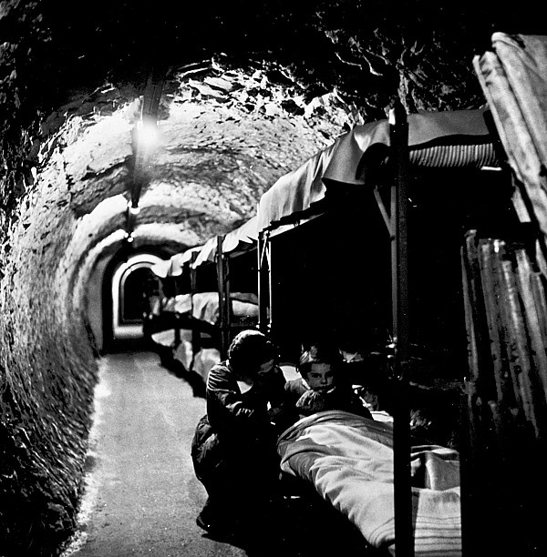

“I hate… all of you…”

The child starts to scratch the bed, seems suffering.

“I must make that girl away…from him…”

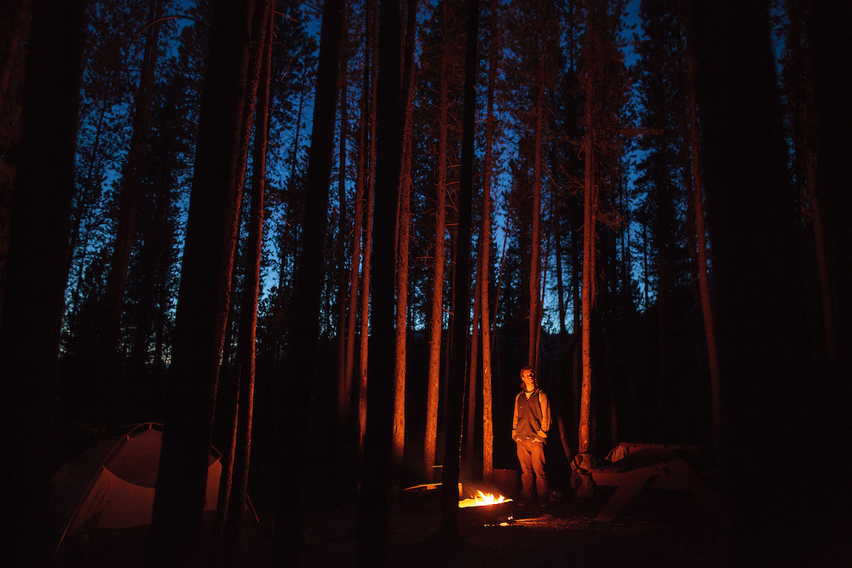

“I was hiding in the bush… mom… father was making a campfire…”

“And…he will do something with that… keep away…keep away”

“**Mom…where are you…**”

The boy starts to look at me.

He takes out a piece of diary.

(**Diary V**)

**Game Over**

Game Designer

Yang Hu

Shu Lin